Sales Performance Analysis Report
Report Title: Sales Performance Analysis – [Month/Quarter/Year]
Prepared by: Aminat Aminu (Data Analyst)
Date: [23rd August 2025]

1. Executive Summary
This project analyzes historical sales data to identify trends, evaluate regional and individual performance, and assess product profitability. Using data analytics techniques—including data cleaning, visualization, and performance evaluation—I generated actionable insights to support data-driven decision-making and optimize sales strategies. The analysis demonstrates my ability to transform complex datasets into meaningful business recommendations that enhance overall performance and drive measurable results.

2. Capstone Project Question
"How can regional sales performance and product profitability be optimized using historical sales data?"
This question frames the analysis and guides the objectives, methodology, and recommendations throughout the project.

3.Strategic Questions to be Answered:
- Which regions generate the highest/lowest revenue?
- Who are the top-performing sales representatives, and what patterns do they show?
- Which products are most profitable or least sold?
- Are there seasonal trends in sales performance?
- What recommendations can be made to improve inventory allocation or sales strategies?

3. Objectives of the Analysis
The main goals of this analysis were to:
- Understand overall sales performance.
- Identify top and low-performing regions and sales representatives.
- Analyze revenue, profit, units sold, and customer behavior.
- Assess product-level profitability and trends.
- Provide actionable recommendations to improve sales and business performance.

3. Dataset Overview
Dataset Name | Source | Rows | Columns | Tools Used
Sales Data | EvolveHQ / Provided dataset |  | [Insert] | Excel / SQL / Power BI
Key Fields definitions:
Field Name | Description
Product_ID | Unique identifier for each product sold.
Product_Category | Category or grouping of the product (e.g., Electronics, Kitchen, etc.).
Sale_Date | The date the sale occurred.
Region | Geographic sales location (e.g., North, South, West).
Sales_Rep | Name of the sales representative responsible for the sale.
Quantity Sold | Number of units sold in each transaction.
Unit Cost | Cost of acquiring or producing one unit of the product.
Unit Price | Original selling price per unit before discount.
Discount | Discount applied to the product (percentage or amount).
Selling Price after Discount | Final selling price after applying the discount.
Sales Amount | Total revenue generated (Selling Price × Quantity Sold).
Total Cost | Total cost of goods sold (Unit Cost × Quantity Sold).
Profit | Earnings after subtracting total cost from sales amount.
Profit Margin | Percentage of profit relative to sales amount.
Profit Status | Indicates whether the sale was profitable or not.
Customer Type | Categorizes customer as New, Existing, or Returning.
Payment Method | Payment channel used (e.g., Cash, Transfer, Card).
Sales Channel | Sales platform used (e.g., Online, In-store, Wholesale).

4. Data Cleaning & Preparation
Key steps performed to prepare the data:
- Removed duplicates and handled missing values.
- Corrected data types (dates, numbers).
- Standardized region and product names.
- Added calculated fields (e.g., Profit Margin, Selling price after discounts, Sales amount, Total cost, Profit).

5. Descriptive Statistics
Metric | Value
Total Sales | ₦ 59,686,173
Total Profit | -₦4,155,920
Total Product Ordered | 25,355
Total Cost | ₦63,842,094
Number of Customers | 1001
Highlights:
- Sales peaked in the first Quarter of the year, showing seasonal trends.
- [Region X] generated the highest revenue while [Region Y] underperformed.
- Top-performing products were [Product A, Product B].

6. Sales Dashboard (Visuals)
Overall Sales Dashboard
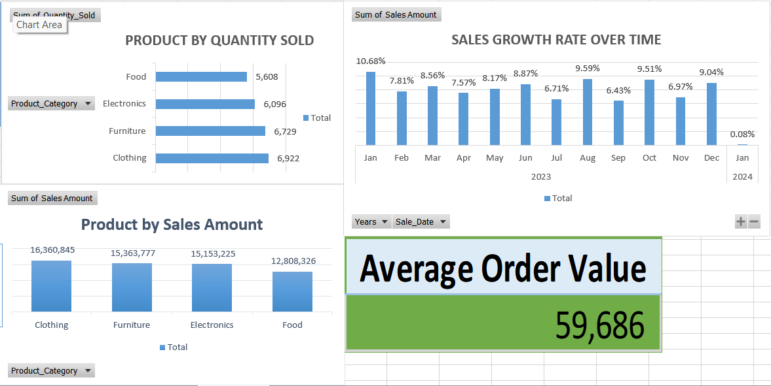
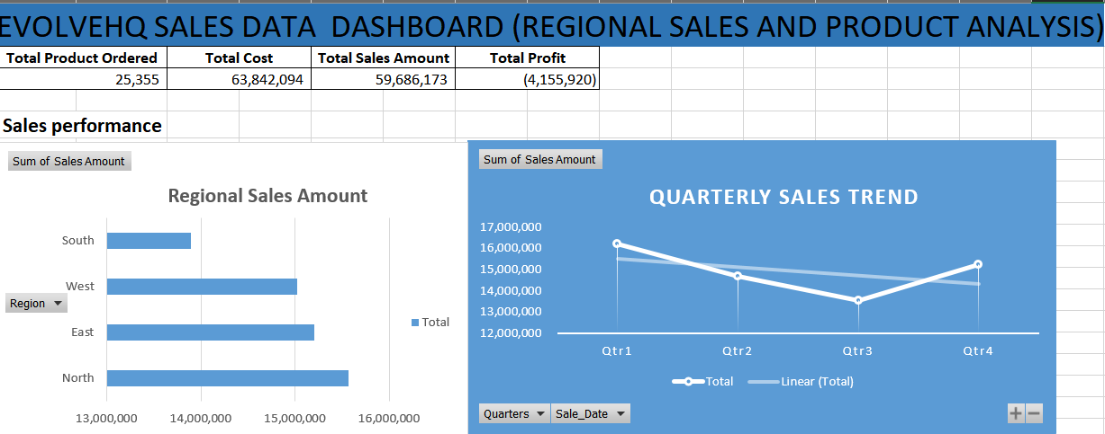
- Sales Performance Metrics

- Sales Rep Analysis
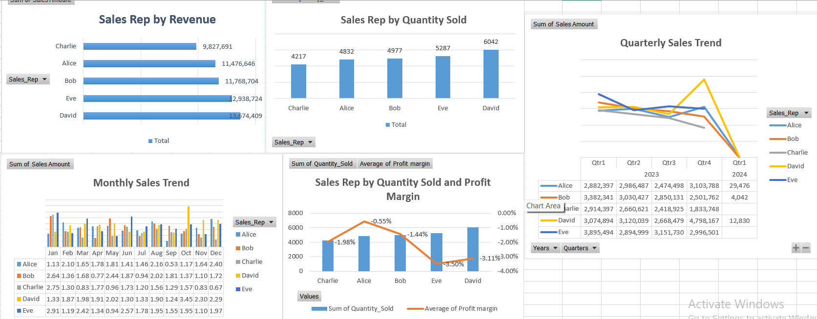
- Regional Insights
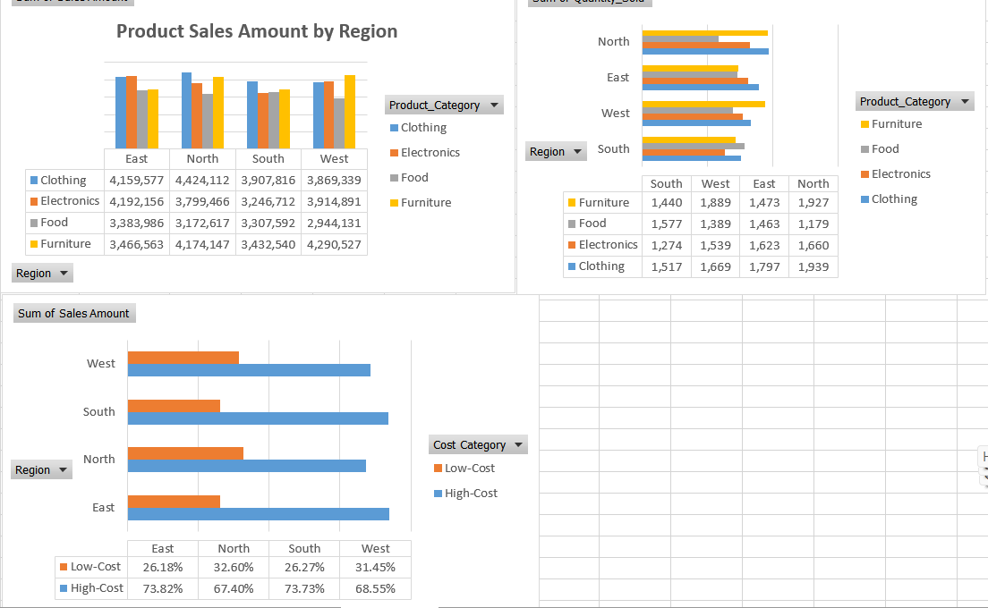

- Product and Inventory Metrics
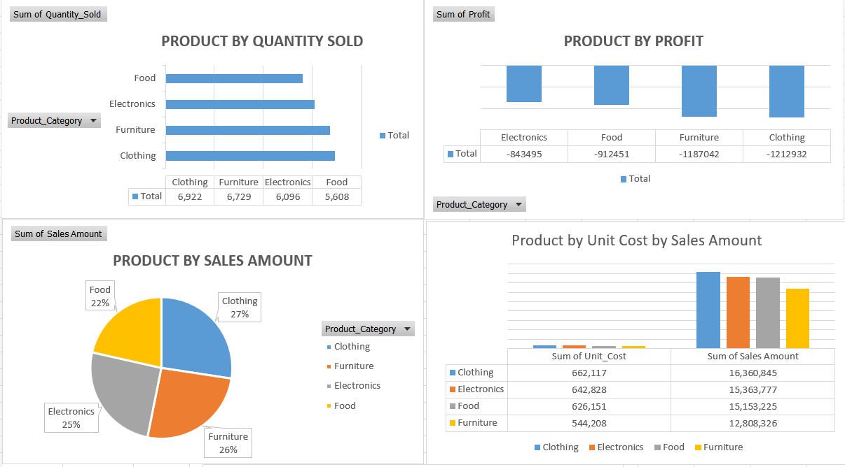

- Revenue by Region
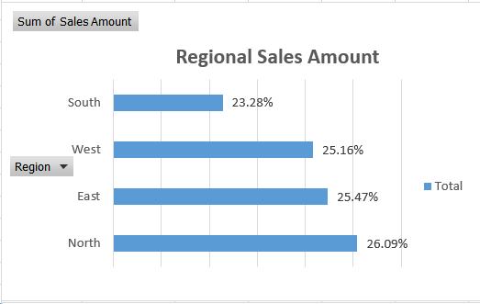
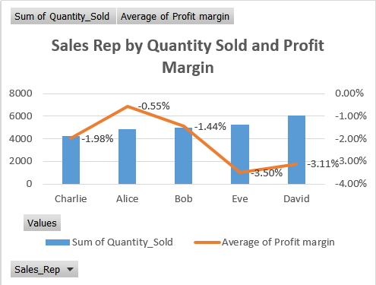
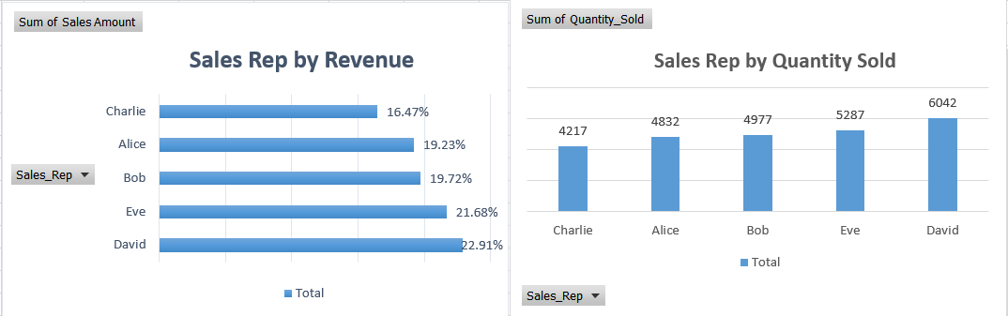
- Top RepresentativesPerforming Sales

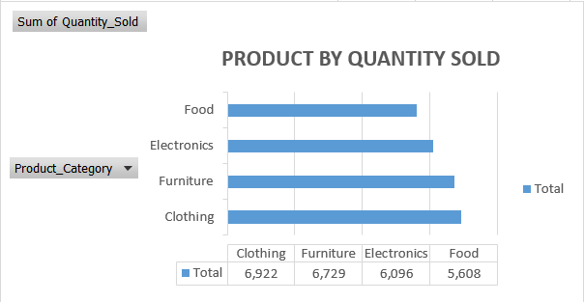
- Best and Worst Performing Products
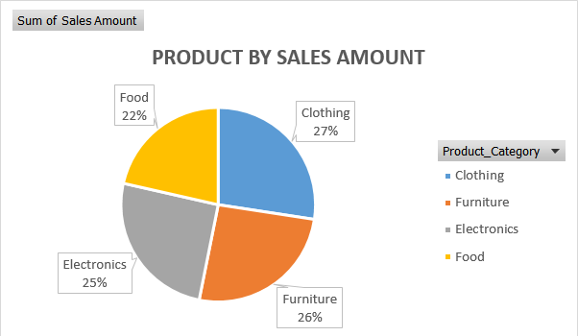

- Seasonal Sales Pattern
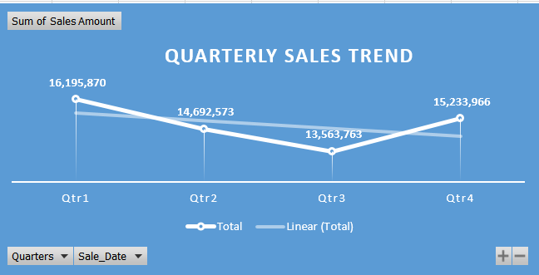
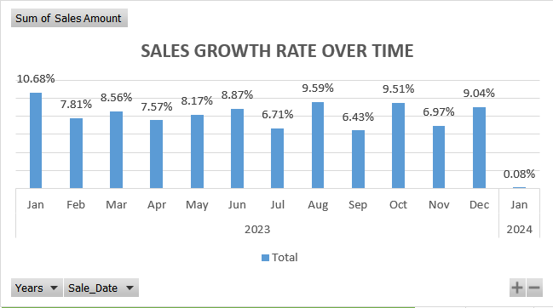

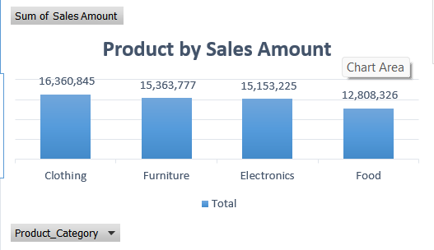
- Sales by Product Category

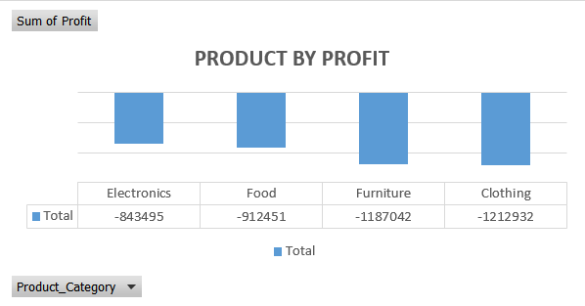
- Customer Segment Analysis

7. Key Insights & Findings
7.1 Revenue by Region
- The North region generated the highest share of revenue at 26.09%, making it the top-performing region.
- The East (25.47%) and West (25.16%) regions follow closely, indicating fairly balanced performance across these areas.
- The South region contributed the lowest revenue at 23.28%, showing potential growth opportunities through targeted marketing or improved distribution.
The South region consistently underperforms compared to other regions, indicating possible gaps in demand, sales coverage, or customer engagement.
7.2 Top Performing Sales Representatives
- David is the top-performing sales representative, contributing 22.91% of total revenue and achieving the highest quantity sold (6,042 units).
- Eve follows closely, generating 21.68% of revenue with 5,281 units sold.
- Bob and Alice contribute 19.72% and 19.23% of total revenue, with 4,977 and 4,832 units sold respectively.
- Charlie comes in last among the group with 16.47% revenue contribution and 4,217 units sold.

Profitability Insight
Despite high sales volume across all representatives, the company incurred losses, as all sales reps recorded negative profit margins:
- Eve: –3.50% (highest negative margin)
- David: –3.11%
- Charlie: –1.98%
- Bob: –1.44%
- Alice: –0.55% (lowest negative margin)

Interpretation
- While David leads in both revenue and quantity sold, Alice performed better in profitability, achieving the least negative profit margin, meaning her sales were managed more efficiently.
- Eve and David’s high negative margins suggest discount overuse, high cost of goods, or inefficient pricing strategies, despite strong sales performance.
- Charlie, although not the lowest in revenue, performed poorly in profitability with a higher negative margin than Alice.
7.3 Seasonal Sales Pattern
- Sales peaked in Q1, indicating a strong start to the year.
- A decline occurred in Q2 and Q3, showing a mid-year slowdown.
- Sales began to recover in Q4, although the overall yearly trend still reflects a general decline.
- There was positive year-over-year growth from January 2023 to January 2024.
- Top-performing months: January, August, October, and December.
- Weakest months: September and July, showing the lowest growth.
- January 2024 growth dropped close to zero, possibly because the new sales cycle had just begun.
- Here is a polished interpretation you can add under your sales trend insights:

Interpretation
The sales pattern suggests strong early-year performance driven by renewed customer demand or seasonal purchasing behavior. The mid-year decline in Q2 and Q3 may indicate reduced customer activity, supply challenges, or lower promotional efforts during that period. The slight recovery in Q4 shows potential for end-of-year sales opportunities, but the overall downward trend highlights the need for improved marketing, better stock availability, or stronger customer retention strategies. The near-zero growth in January 2024 reflects the typical slowdown that occurs at the beginning of a new fiscal year before sales momentum builds.
7.4 Best and Worst Performing Products
- Clothing is the best-performing product category, contributing 27% of total revenue with 6,922 units sold.
- Furniture follows closely, generating 26% of total revenue and 6,729 units sold.
- Electronics accounts for 25% of revenue, with 6,092 units sold.
- Food is the lowest-performing category, contributing 22% of total revenue with 5,608 units sold.

Interpretation
Clothing and furniture drive the highest revenue and sales volume, indicating strong customer demand and consistent performance across both categories. Electronic is slightly behind in both revenue and units sold. The food category has the lowest contribution, suggesting either lower demand, pricing challenges, or limited product variety. The company may need targeted promotions, improved pricing strategies, or expanded product offerings to boost sales in the food category.

Product Profitability Analysis – Key Insights
- All product categories recorded negative profit, indicating the company is operating at a loss across all product lines.
- Clothing has the highest loss, with a total negative profit of ₦1.21M.
- Furniture follows closely with a loss of ₦1.18M.
- Food recorded a loss of ₦912,451.
- Electronics had the lowest loss, at ₦843,495, but still remains unprofitable.

Interpretation
The negative profit across all product categories suggests systemic issues rather than isolated product problems. This could be due to high unit costs, excessive discounting, operational inefficiencies, or pricing strategies that do not cover total costs. Clothing and furniture, despite being the highest revenue generators, are also the most unprofitable—likely because their cost-to-sales ratios are extremely high. Electronics, though generating lower revenue compared to clothing and furniture, shows relatively lower losses, which may indicate better cost control or higher pricing efficiency. Overall, profitability improvement will require revisiting pricing strategy, reducing operational costs, and optimizing discount policies.

8. Recommendations

1. Adjust Pricing and Discounts Strategy
- Reduce unnecessary discounts
- Increase prices slightly where possible
- Focus on selling items that can bring better profit

2. Review and Optimize Cost Structure
- Check supplier prices
- Reduce high operational costs
- Look for cheaper alternatives without reducing quality

3. Improve Inventory Management
- Stock more of high-demand items (Clothing and Furniture)
- Reduce overstock of slow-moving items
- Use sales trends to plan inventory better

4. Improve Product Performance
- Promote and bundle low-performing products like Food
- Focus marketing efforts on best-selling categories
- Introduce seasonal promotions to increase sales

5. Strengthen Sales Team Performance
- Study how top reps (David and Eve) sell and share their methods with others
- Encourage reps to sell more profitable items, not just high-volume items
- Reduce over-reliance on discounts during sales

6. Improve Customer Retention
- Encourage returning customers with small rewards or loyalty offers
- Use customer type data (new vs returning) to plan better promotions

7. Monitor Profitability Regularly
- Create simple monthly reports showing:
  - Profit or loss by product
  - Revenue by region
  - Discount impact
- This helps the company respond faster when profits start dropping.

9. Tools & Skills Demonstrated
- Data Analysis: Excel
- Data Visualization: Excel charts
- Skills: Data cleaning, trend analysis, performance evaluation, reporting, actionable insights generation

10. Conclusion
This analysis highlights important sales trends, top-performing regions, products, and customer patterns, as well as areas that require improvement. By applying data analytics techniques, the project demonstrates how data-driven insights can support better decision-making, optimize sales strategies, and improve overall profitability.

